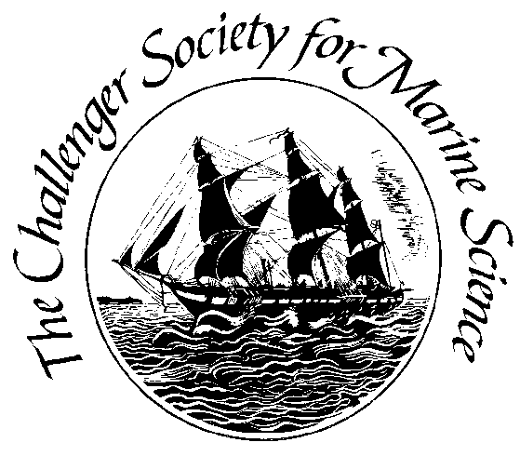
Summary
145th MEETING OF THE CHALLENGER SOCIETY COUNCIL

1-4pm 11th March 2026

We welcomed a new member to the Challenger Society Council: Peter Sheehan from the University of East Anglia, who will be taking over the Special Interest Group (SIG) portfolio.

Maeve Lohan (University of Southampton) gave her president’s update on the Future Marine Research Infrastructure (FMRI) project and the Marine Science UK initiative. The Council are supportive of continued engagement between FMRI and Challenger, and hope to have fruitful dialogues going forward. Marine Science UK now have a website up-and-running (https://marinescience.org.uk/), and are beginning to gain members. They are still hoping to have a launch event in May, which will be circulated to Challenger members when possible. It was noted that the NOC Association (NOC-A) has timetabled a discussion of the group’s future in the light of Marine Science UK at their upcoming meeting.

It’s the time of year when the CSMS Council are looking for nominations for Challenger fellowships and the Challenger Medal! We appreciate that there’s a need to advertise these awards to as broad a section of the community as possible. Kate Hendry (BAS) will be organising a nomination committee, including SIG leads, to broaden subject areas of nominees, and we will be working on emailing to the membership and using social media to cast the nets far and wide.

Alex Brearley (BAS) gave an update as Honorary Treasurer on our accounts. We’re delighted that constructive conversations with Marine Biological Association (MBA) have led to an agreement that they will support the CSMS by contributing to the UK SCOR fees. We’re also thinking of other ways to gather more support to help fund SCOR activities. We are also looking into options to boost fundraising in general, and will produce a paper with options for the next Council meeting, whilst doing full due diligence for the community.

Chelsey Baker and Anthony Lucio (NOC) have been working tremendously hard on the redesign and management of membership subscriptions via a new, user-friendly membership platform. There are a few outstanding activities and a few queries, but we’re getting close to having a functional platform that can support the payment of fees via PayPal.
Tom Rippeth (Bangor) gave an update on Challenger Conference plans. We’re so excited to hear the plans taking shape for keynotes, parallel sessions, the medal talk, the icebreaker, excursions and the dinner! More will be available soon, including registration and abstract submission, via the CSMS website. The President’s Art Prize will be going ahead – so keep an eye out for more information soon! There were also updates from Robyn Tuerena (SAMS) on the Education and Outreach portfolio, with lots of exciting activities that will link in with the Conference.

Alex Poulton (Herriot Watt) gave an update on SCOR activites. The Royal Society, again, have agreed to pay 49% of the UK’s annual membership to SCOR. The remaining costs are covered by CSMS, with generous support from NOC, SAMS and now (as stated above!) MBA. There are two new UK SCOR vice-chairs: Alice Marzocchi and Will Homoky. UK SCOR volunteered at SCOR booth at AGU Ocean Sciences Meeting (OSM) in Glasgow in February, which was very constructive. Alex has also joined the nominating committee for SCOR executive, and has applied to be on finance committee. CSMS members might be interested to know that SCOR are advertising for an ECR representative on the Executive Committee.

Chris Auckland (UEA) has carried on fantastic work with travel grants and Stepping Stones Bursaries. Thanks to Chris, we’re clarifying our eligibility criteria for these bursaries, in order to support applicants, specifically Masters students. Peter Sheehan is already active in prompting SIG leads to update him on activities, and to engage with the Challenger Conference.
Gillian Damerell (Bergen) reported that CSMS (jointly with IMECaN and TOS) had a successful and lively townhall at OSM on "Broadening the Ocean Science Workforce for a More Equitable, Inclusive, and Engaged Community". Although several people contributed, Gillian thanked Chelsey specifically as being the driving force behind this event, and CSMS for paying the Townhall fee.

