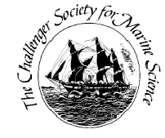
Challenger Society for Marine Science
Chris Daniels Award Application Form
- The Society cannot guarantee that an award will be made and this should not be assumed in applying for funding elsewhere.
- Deadlines for applications are April 1st
Please refer to the more detailed guidance when completing this form, which can be found at https://www.challenger-society.org.uk/Chris_Daniels_Early_Career_Grant
Name: | Email:
Address:  Challenger Membership no.: | Address for  payment, if  different
Event: | Location:
Summary of planned event: | Breakdown of costs:  Approx total cost:
Please identify source and amounts of funding apart from the CSMS Chris Daniels award:

Please state how much funding from the Challenger Society you are applying for:
I agree to write a report | Your submission date for report (must be a maximum of 3 months after the event):
Full description of event and activities (see applicant guidelines):

Benefit of event and activities to early career researchers:

Applicant Signature: | Date:

Please complete this form and return it with a CV and letter of support (see applicant guidelines) to Prof Kate Hendry (kathen@bas.ac.uk).

