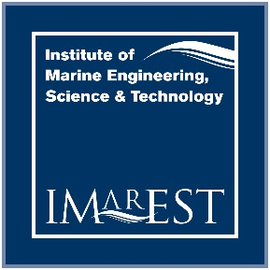
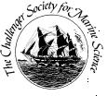

The Tripartite Challenger / IMarEST / SUT Undergraduate Award

The Challenger Society for Marine Science (CSMS), the Institute of Marine Engineering, Science and Technology (IMarEST) and the Society for Underwater Technology (SUT) are pleased to announce the creation of a new undergraduate prize. The prize is worth £500 and is awarded each year to an undergraduate student enrolled on a full time Bachelor’s degree course in marine science, engineering or technology at a UK University or College. The award is based on a written application including an abstract written by the applicant about his/her final year dissertation submitted before the end of April with a recommendation from their supervisor. Six candidates will be shortlisted from the applications who will be required to submit their full dissertation report by the end of May to be judged by an expert panel.

For details contact

Dr Bev Mackenzie (bev.mackenzie@imarest.org) IMarEST Technical and Policy Director.

Dr John Bacon, (john.bacon@cefas.co.uk). Challenger Society Honorary Secretary.

To download criteria and an application form please visit http://www.imarest.org/membership/awards-scholarships/undergraduate-awards

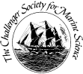

Challenger Society for Marine Science, Institute of Marine Engineering Science and Technology and Society for Underwater Technology Undergraduate Prize

Criteria

Introduction

The Challenger Society for Marine Science (CSMS), the Institute of Marine Engineering, Science and Technology (IMarEST) and the Society for Underwater technology (SUT) has a competitive award scheme to support students studying for a Bachelor’s degree in Marine Science or Technology at a UK University or College. The scheme is based on a single payment of up to £500 to the successful student. It is envisaged that one award will be awarded each year.

The Award

Title: The Marine Science and Technology Tripartite Award Award: One award of up to £500 will be awarded each year.
Eligibility: Final Year students enrolled on UK University or College Marine Science or Technology courses. Applicants must be student members of either the CSMS, IMarEST or SUT. An individual will only be eligible for one undergraduate dissertation award from the awards schemes of any of these three Societies.

Procedure

At the beginning of each academic year CSMS, IMarEST and SUT will circulate details of the scheme to the Heads of Department at all Universities and Colleges with appropriate courses, inviting them to submit applications from students in their departments. The applicants and their sponsors will be required to complete an application form setting out details of their course and an abstract written by the applicant about his/her final year dissertation by the closing date at the end of April. A recommendation by his/her sponsor is also required. Shortlisted candidates will then be required to submit their full dissertation by the end of May of that same year (the candidates’ final year). The award will be announced at the IMarEST, Challenger Society and SUT annual meetings.

Assessment

The applications will be assessed against predetermined criteria by a scholarships subcommittee made up of members representing each of CSMS, IMarEST and SUT who will shortlist six candidates for the award. The subcommittee will then have sole responsibility for awarding the available scholarship from the submitted dissertations.

Application

Applications for the prize can be downloaded as a word document at http://www.imarest.org/membership/awards-scholarships/undergraduate-awards. Please email your completed application form to tripartite.award@challenger-society.org prior to the closing date on 30th April 2016.

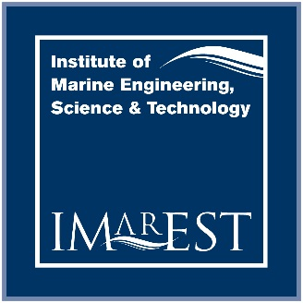

Application for the IMarEST/ CSMS/SUT Undergraduate Award

PLEASE COMPLETE THIS FORM IN BLOCK CAPITALS IN BLACK INK AND 'DELETE AS APPROPRIATE’. DISSERTATION ABSTRACT, APPLICATION FORMS AND NOMINATIONS BY THE UNIVERSITY, COLLEGE OR ACADEMY MUST BE RECEIVED AT THE ADDRESS BELOW BY LAST WORKING DAY OF APRIL 2016. FULL DISSERTATIONS MUST BE SUBMITTED AT THE END OF JUNE 2016.

I apply for the IMarEST / CSMS/SUT Undergraduate Award

Name
Forename(s) (in full)

Address (to be used in all correspondence)

Have you made a previous application?

Yes/ No (delete as applicable)

E-mail address (Institution Email)

Daytime Tel. No.

E-mail address (Personal Email)

University Registration Number

Course of Study
Current Course (Please include the titles of all modules that you have studied or are studying for the course)
Date joined course
University/College
Length of course (years)

Abstract

Please write a short abstract of the research that will be undertaken in your final year dissertation. This should include a brief background to the topic and the aims and objectives of the work. Max 300 words.

Endorsement by Sponsor (must be a member of staff, preferably research supervisor)

Please report on student's performance, achievements, motivation and potential

Signature of Applicant Date

I certify that
Name of applicant
has been formally nominated by the as a candidate for this award Signature of sponsor
Name in capitals Date

NB: Forms should be submitted by email to tripartite.award@challenger-society.org by 30th April 2016

